**CP Club 365Days Challenge**

**Date – 05/12/2022**

**Programming language – c++**

**Problem Statement**

[https://practice.geeksforgeeks.org/problems/largest-number-with-given-sum-1587115620/1?page=2&category[]=Greedy&sortBy=submissions](https://practice.geeksforgeeks.org/problems/largest-number-with-given-sum-1587115620/1?page=2&category%5b%5d=Greedy&sortBy=submissions)

**Your Code**:

// 0x49Day of 0x365Days challenge

// VEDANT BHARAD

// 05-12-2022

//{ Driver Code Starts

#include <bits/stdc++.h>

using namespace std;

// } Driver Code Ends

// Function to return Largest Number

class Solution

{

    public:

    //Function to return the largest possible number of n digits

    //with sum equal to given sum.

    string largestNumber(int n, int sum)

    {

        if(9*n<sum)

        {

            return "-1";

        }

        else {

            string numtoret;

            for(int loop=0;loop<n;loop++)

            {

                if(sum==0)

                {

                    numtoret+='0';

                }

                else if(sum>=9)

                {

                    numtoret+='9';

                    sum=sum-9;

                }

                else if(sum<9){

                    numtoret+=to_string(sum);

                    sum=0;

                }

            }

            return numtoret;

        }

    }

};

//{ Driver Code Starts.

int main()

{

    //taking testcases

    int t;

    cin>>t;

    while(t--)

    {

        //taking n and sum

        int n,sum;

        cin>>n>>sum;

        Solution obj;

        //function call

        cout<<obj.largestNumber(n, sum)<<endl;

    }

    return 0;

}

// } Driver Code Ends

**Output (Screen Shot)**:

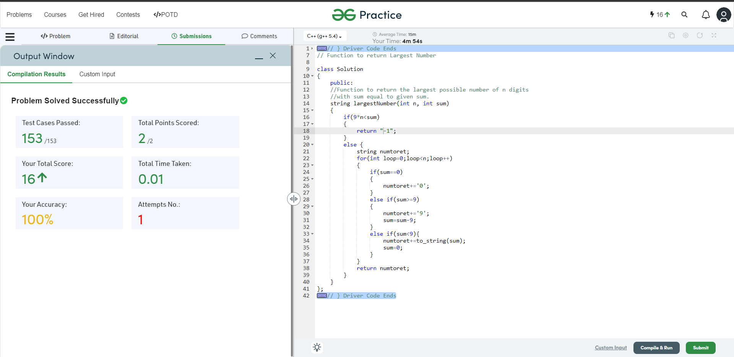

**Understanding about problem:**

In this task I need to make password form that two input N and S and return as a string

Note: If you can't understand the problem, feel free to contact us and we'll help you. Please don't copy and paste from anywhere.

ALL THE BEST

Team CP Club